High quality Benzyl Benzoate CAS 120-51-4 with factory price
Description
benzyl benzoate is a colorless or pale yellow viscous transparent liquid. In temperature conditions of 17 degrees centigrade or lower, it will be solidified into white solid. Benzyl benzoate of high-purity would send out slight fragrance.
Specification
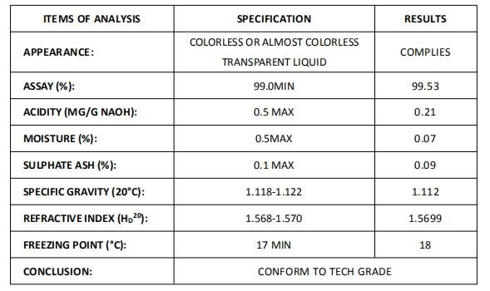​​
Application
Benzyl benzoate is mainly used in the area of textile auxiliary, fragrance and flavor, pharmacy, plasticizer and so on.
Packing and shipping
packing:225kg/drum or as clients' requirements.
shipping: 20 days after signed contract

